Name：Eman Fatima
Reg No: BSSE-23S-0025
Program: BSSE
Date: August 25th, 2026

WEEK NO. 1-

PART A: C# AND .NET BASICS

Exercises:-

Calculator
Code:
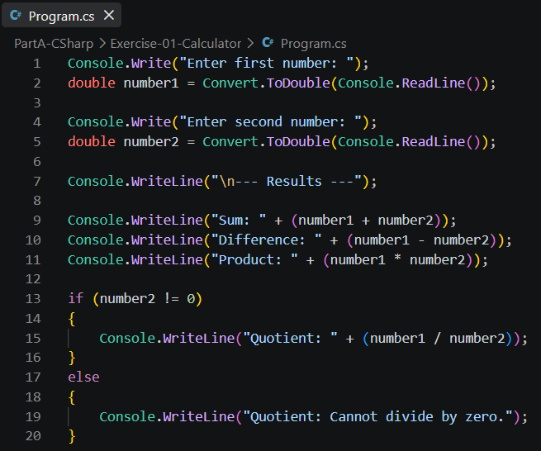
Output:
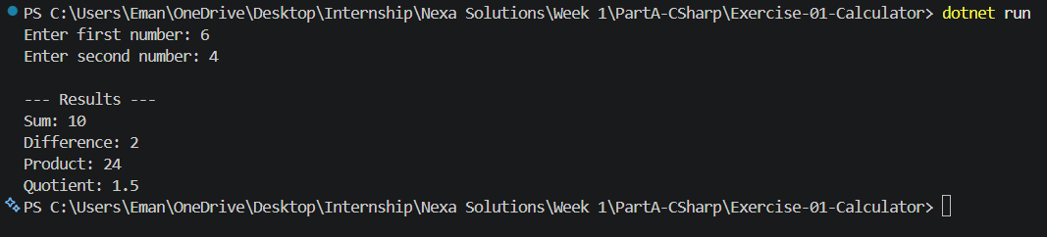

Even or Odd
Code:
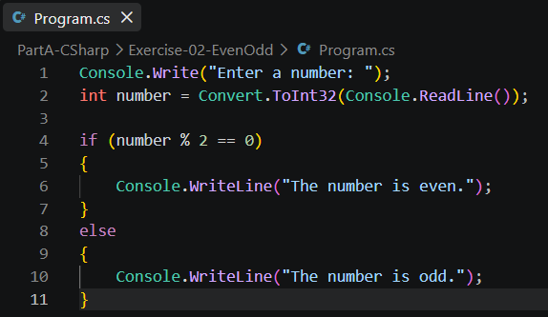
Output:
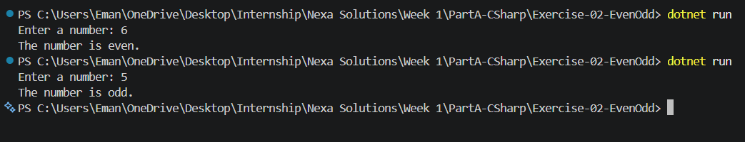

FizzBuzz
Code:
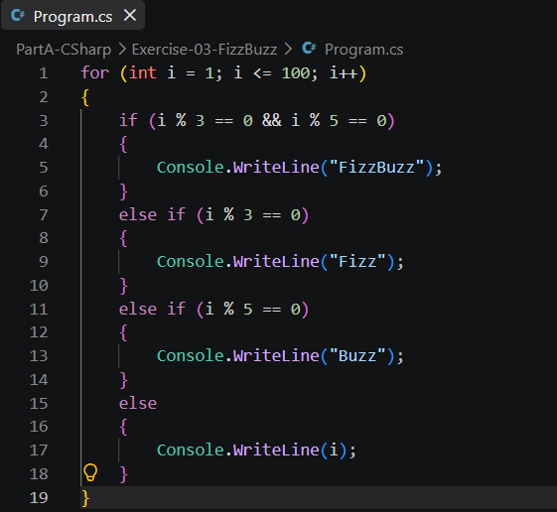
Output:
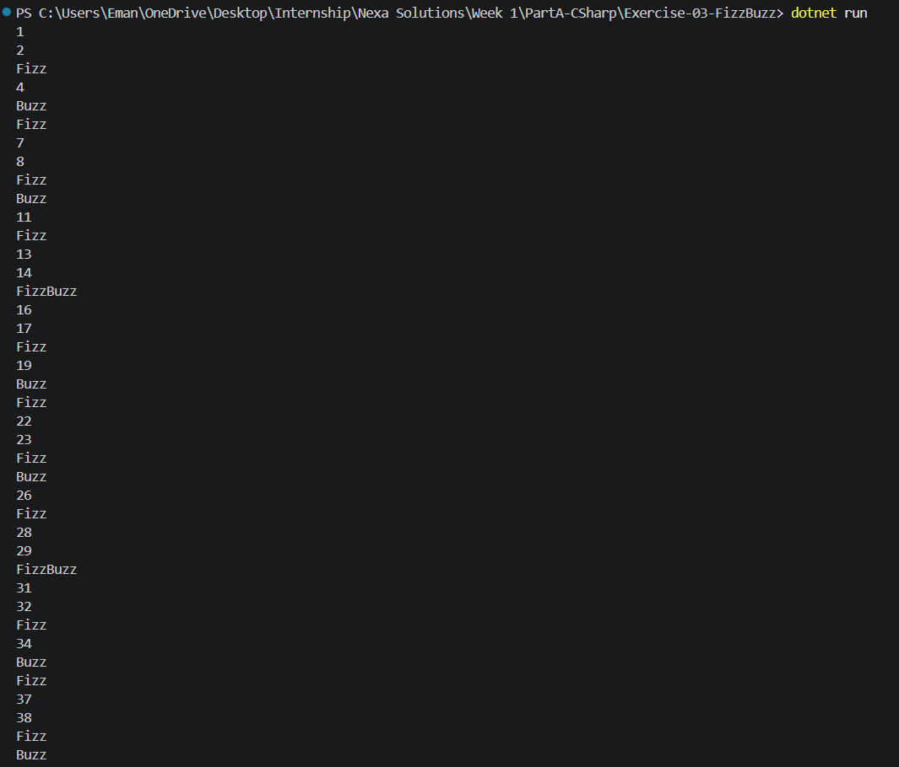
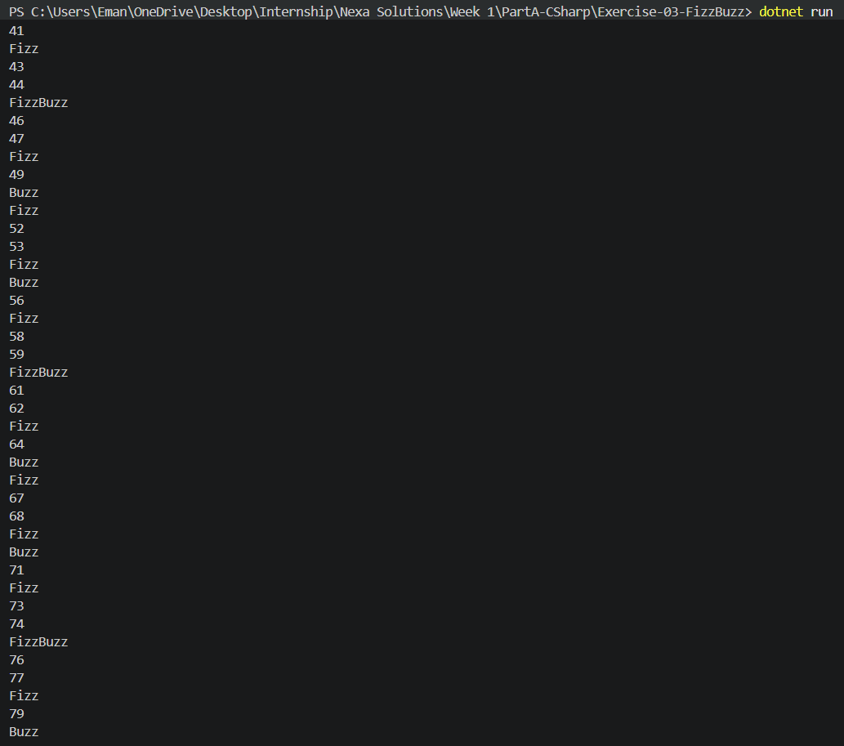
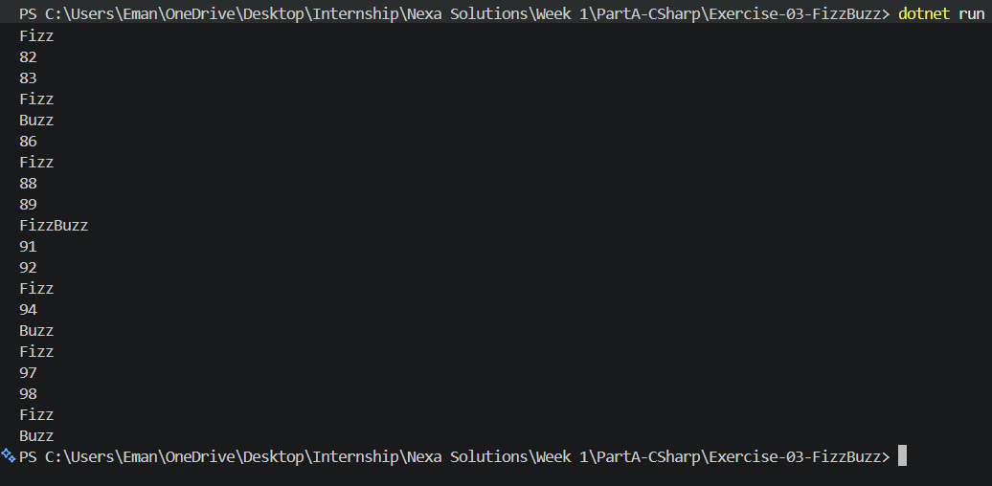

Method That Returns a Grade
Code:
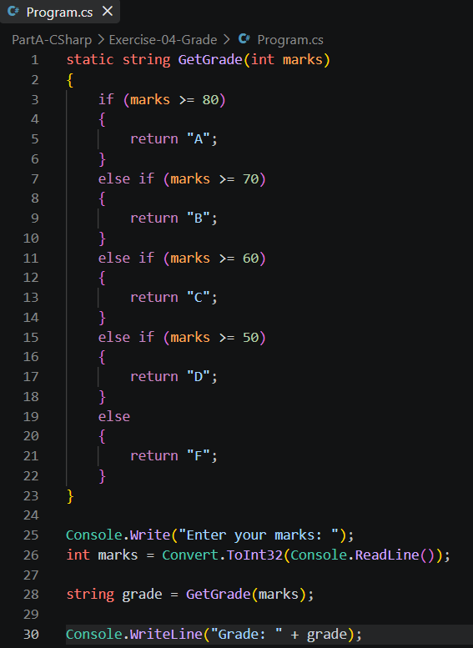

Output:
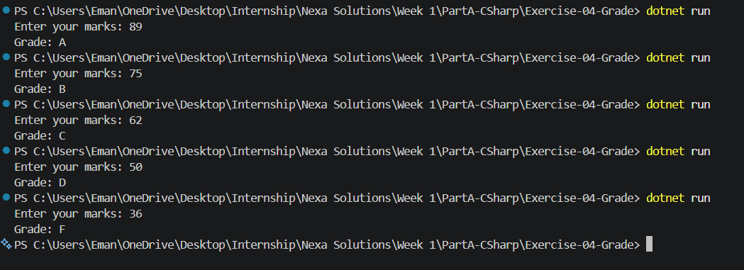

Largest and Smallest
Code:
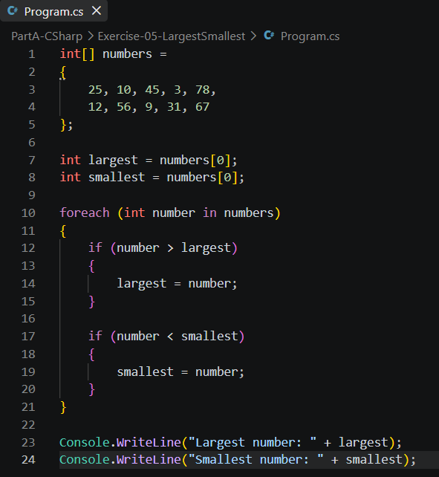
Output:

Menu-Driven Console Program
Code:
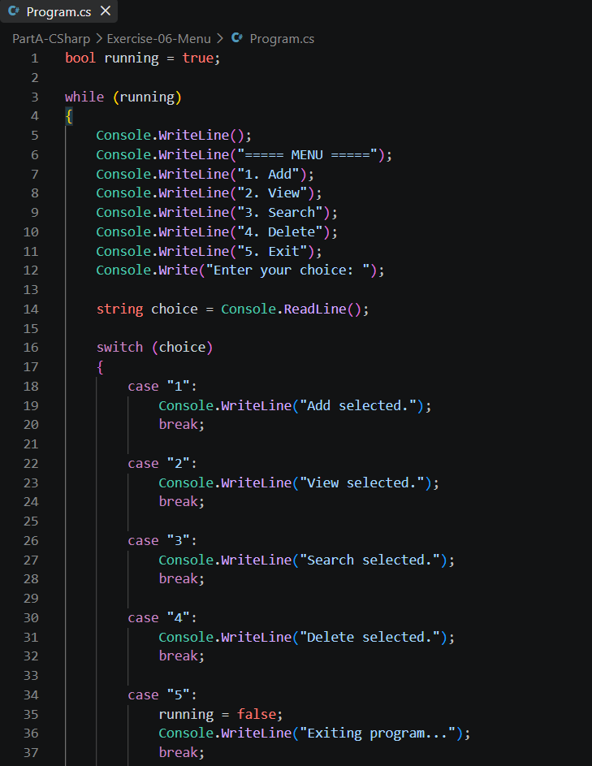
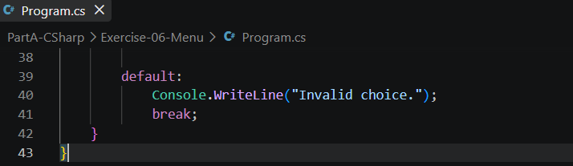
Output:
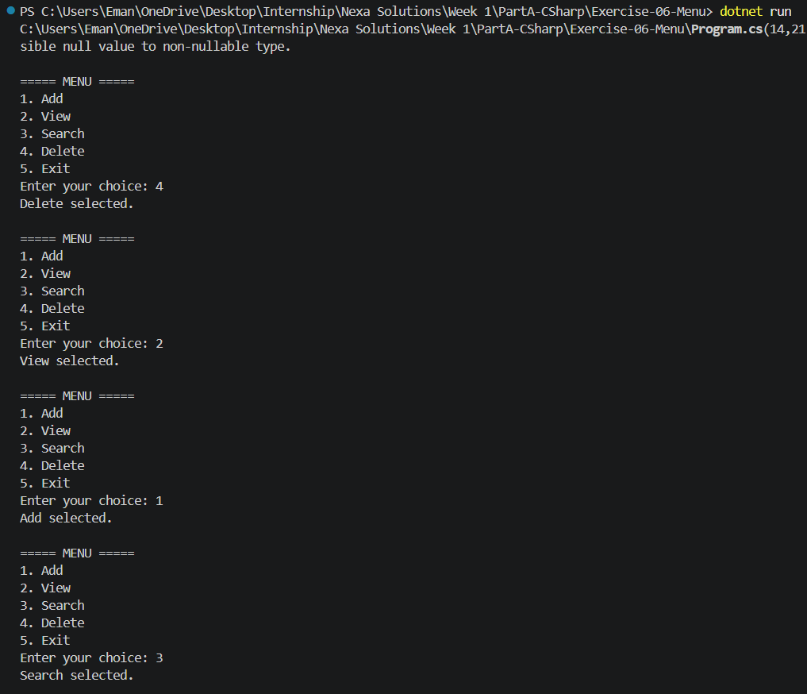
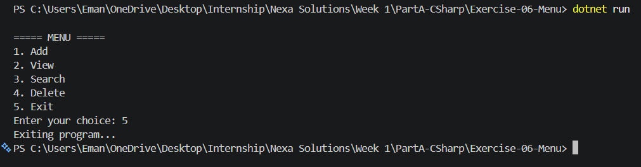

PART B: OBJECT-ORIENTED C#

Exercises:-

Create a Person Class
Code:
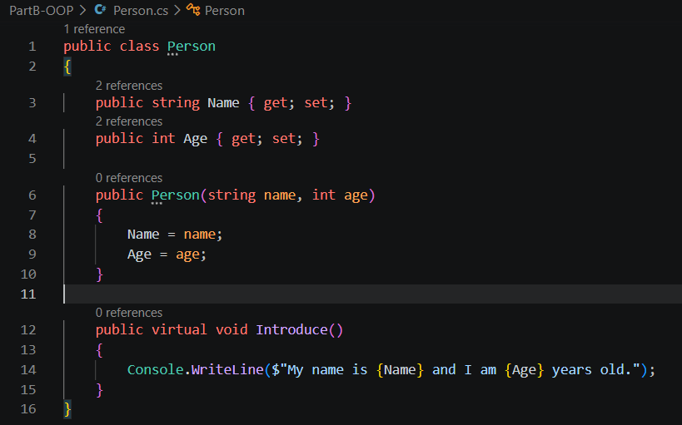
Output:
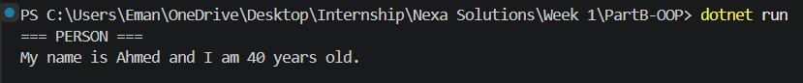

Create Student and Teacher Classes Using Inheritance
Code:
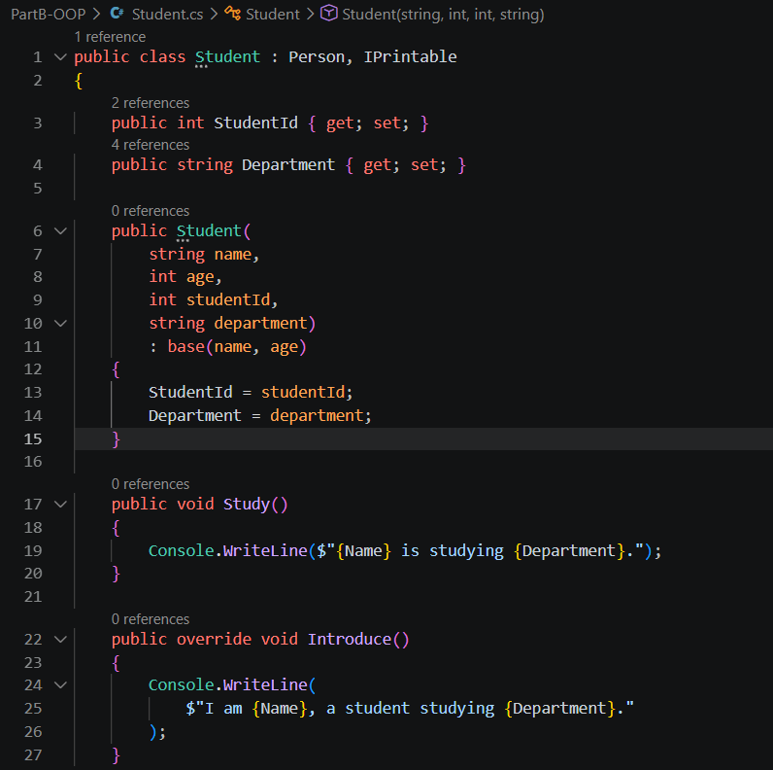
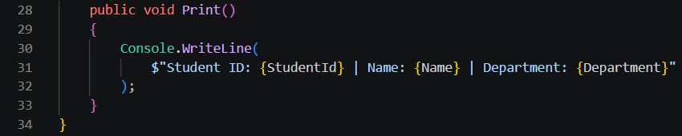
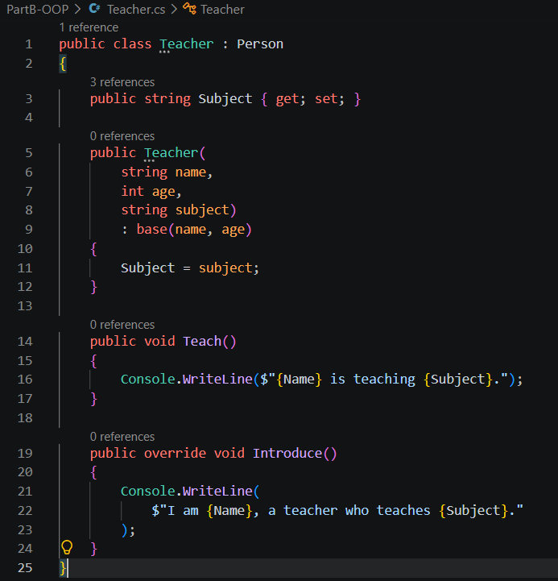
Output:
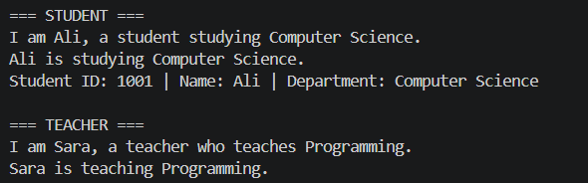

Create and Implement an IPrintable Interface
Code:
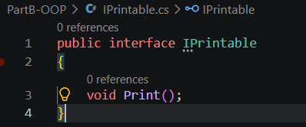
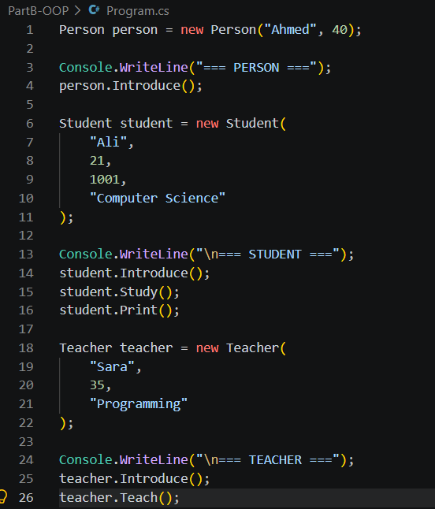

Output:
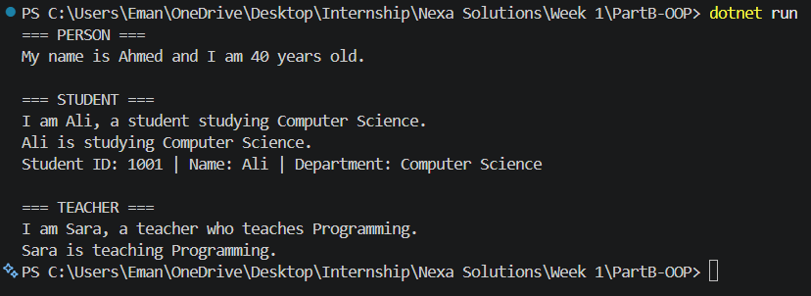

Inheritance vs Composition
Inheritance:
Inheritance makes sense when there is an "is-a" relationship between two classes.
For example;
- A Student is a Person.
- A Teacher is a Person.
Therefore, Student and Teacher can inherit from Person.
Composition:
Composition makes sense when there is a "has-a" relationship.
For example;
- A Student has a Course.
- A Teacher has a Department.
A Student is not a Course, so Course should not be the parent class of Student. Instead, a Student can contain or use a Course object.

Inheritance is useful for "is-a" relationships, while composition is useful for "has-a" relationships. Composition can be better when we want to combine different objects without creating a complicated inheritance structure.

PART C: COLLECTIONS, EXCEPTIONS, AND LINQ

Exercises:-

Create a List and Add Five Students
Code:
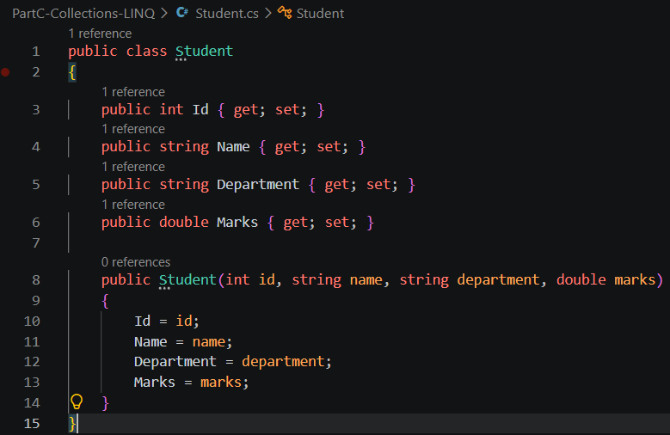
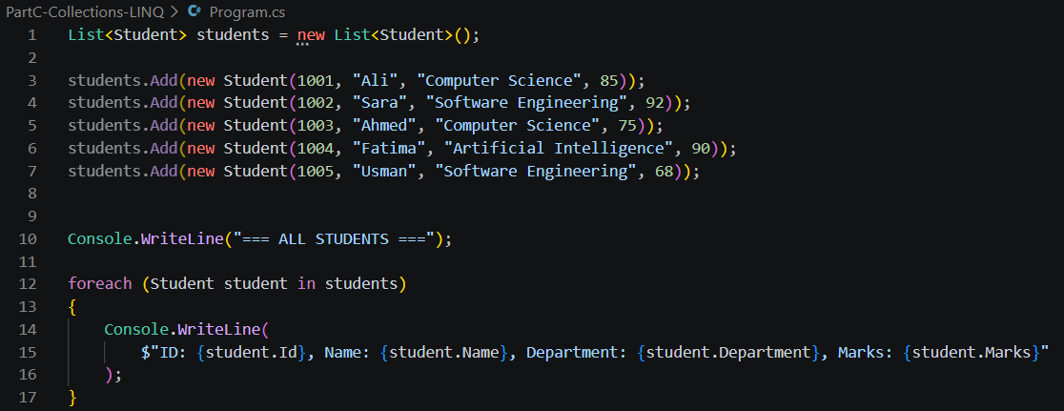
Output:
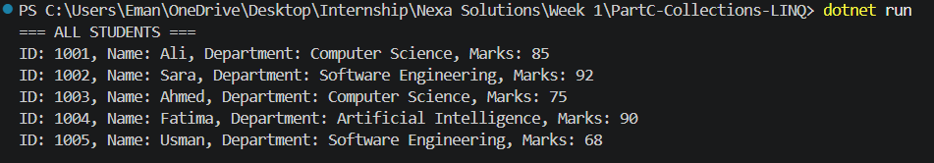

Find Students from a Particular Department Using LINQ
Code:
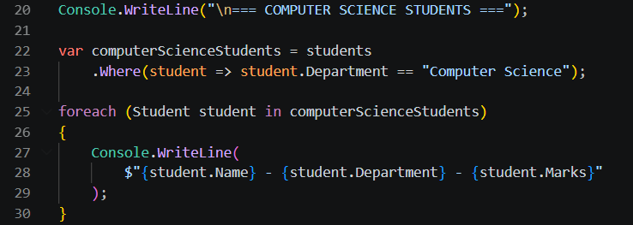
Output:
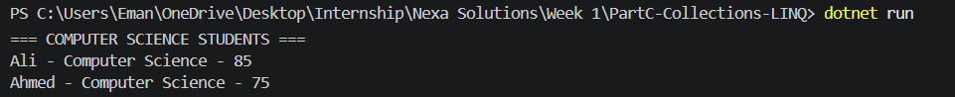

Sort Students by Marks
Code:
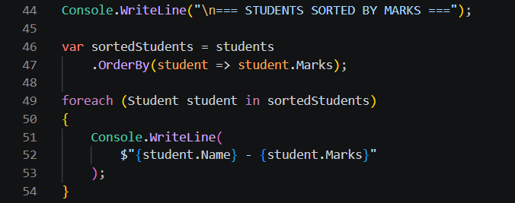
Output:
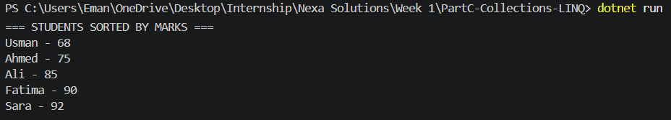

Find a Student by ID
Code:
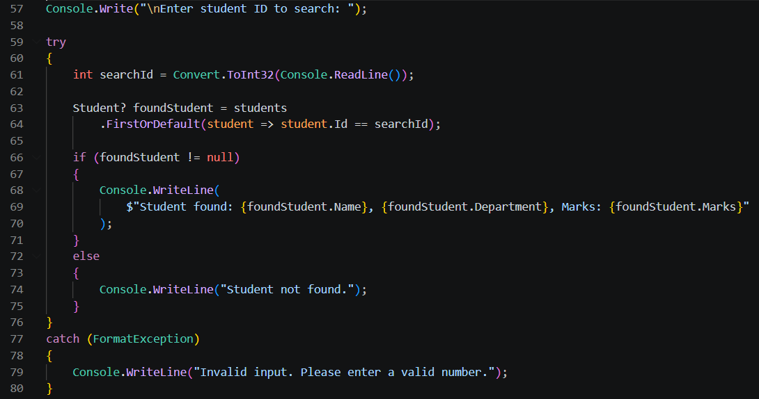
Output:

Handle Invalid Numeric Input
Code:
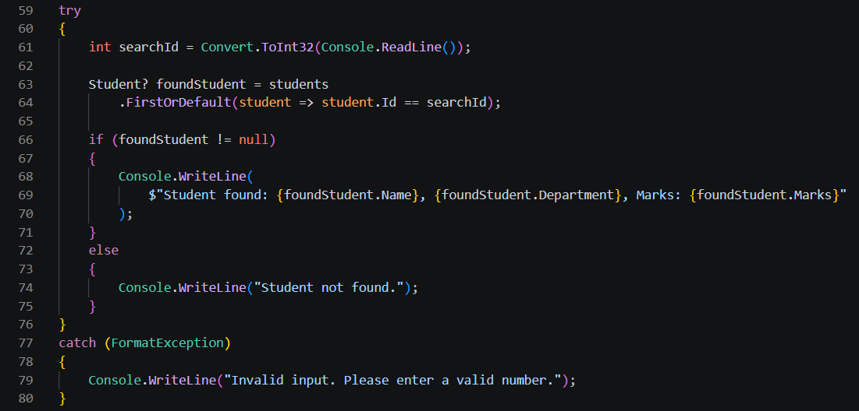
Output:

PART D: ANGULAR AND TYPESCRIPT BASICS

Exercises:-

Create a Simple Angular App That Displays Your Name and Internship Title
Code:
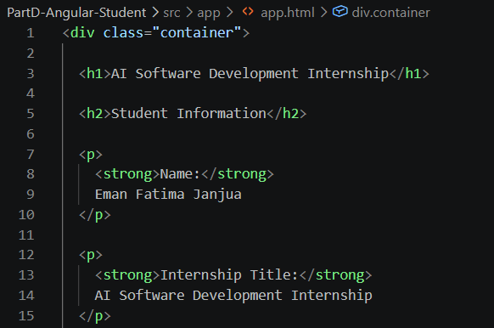
Output:
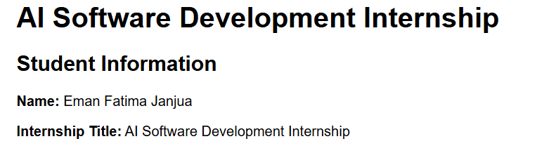

Create a Student Interface in TypeScript
Code:
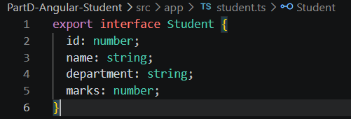
Output:
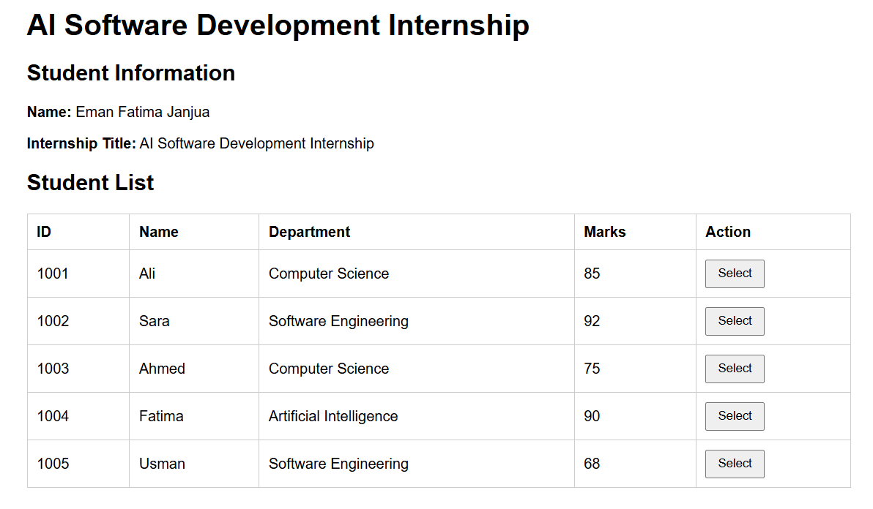

Create an Array of Students and Display Them in a Table
Code:
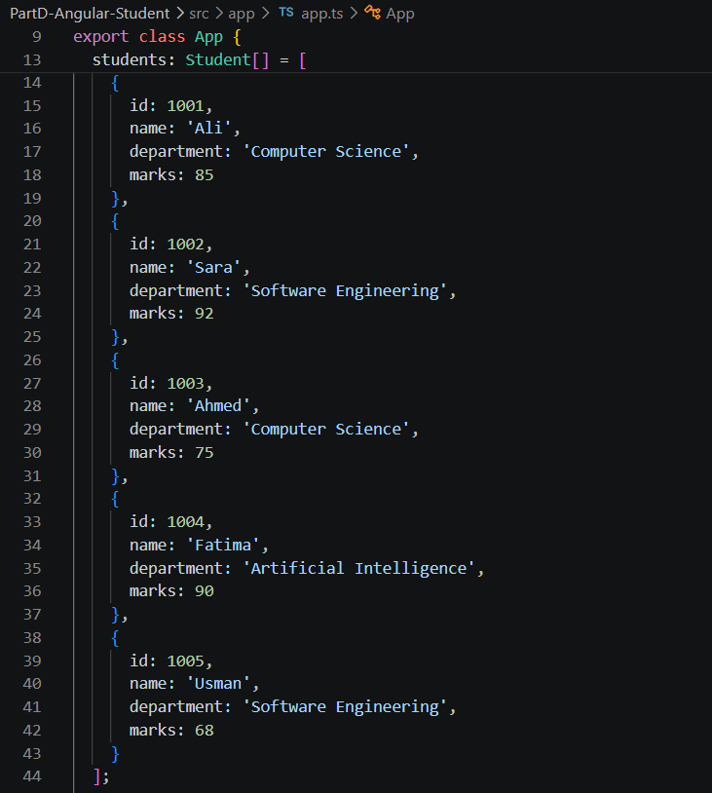
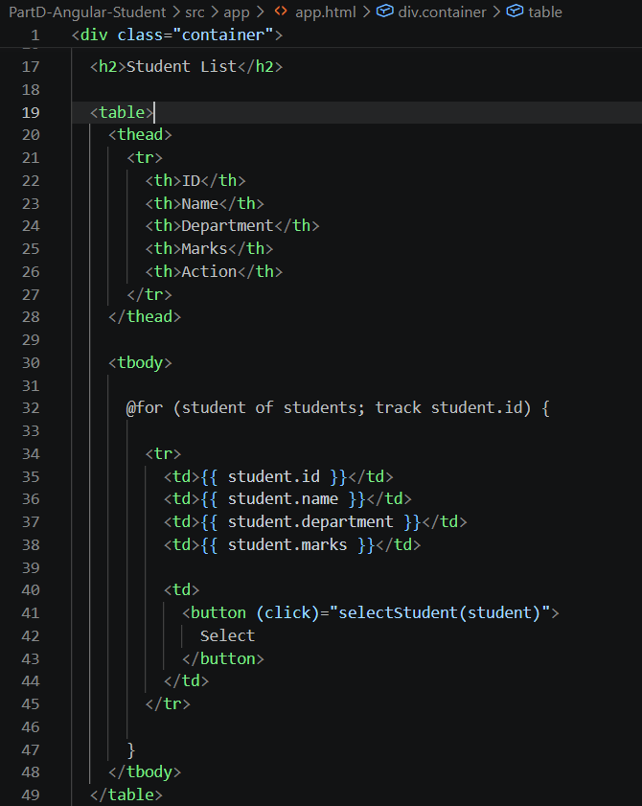

Output:
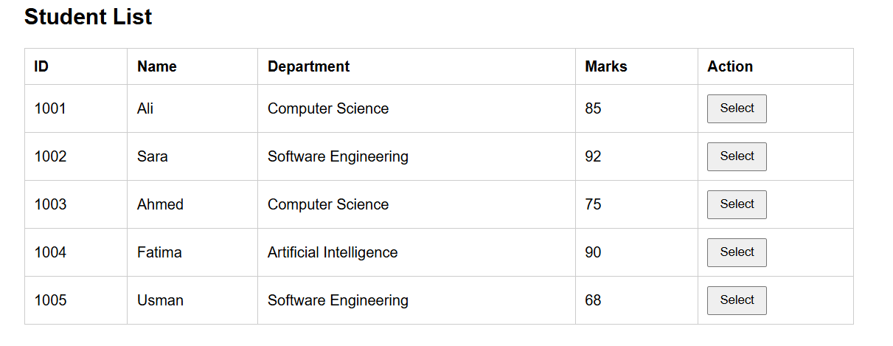

Add a Button That Selects a Student and Shows Their Details
Code:
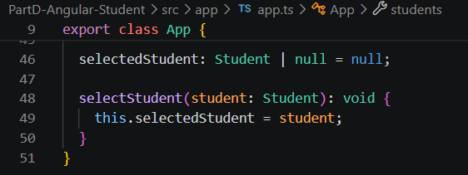
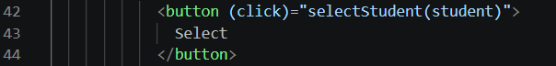
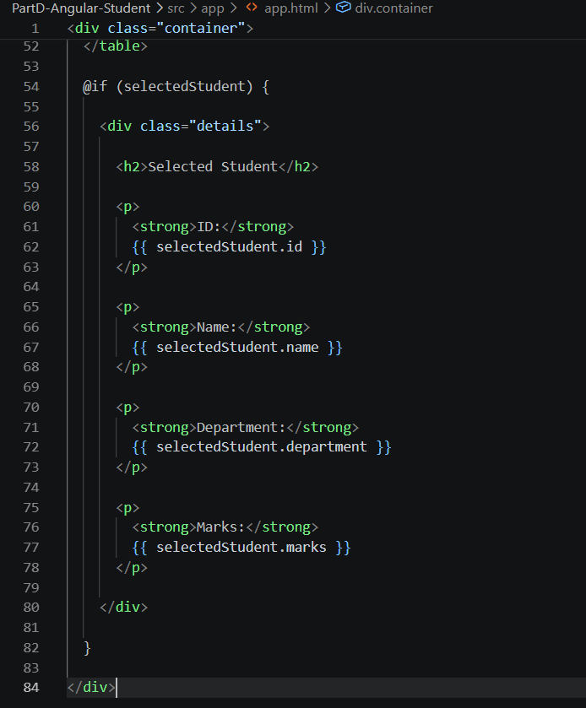
Output:
